2017-03-01

Bryan Greener

Chad Hirsch

Jason Gunderson

Workshop 7.28 7.36

**7.28**

a.) Ho=3421.7

Ha=µ>3421.7

b.) xbar = 3077

xbar

se = 987/sqrt(114)

se

# t-value

tobs = (xbar-3421.7)/se

tobs

# p-value

2*pt(tobs,113)

2*(1 - pt(abs(tobs),113))

= 0.0003023281

c.) xbar = 3077

xbar

se = 987/sqrt(114)

se

# t-value

tobs = (xbar-3421.7)/se

tob

# p-value

2*pt(tobs,113)

2*(1 - pt(abs(tobs),113))

tval = qt(0.975,113)

tval

lower = xbar - tval*se

upper = xbar + tval*se

c(lower, upper)

= 2893.858 3260.142

**7.36**

a)

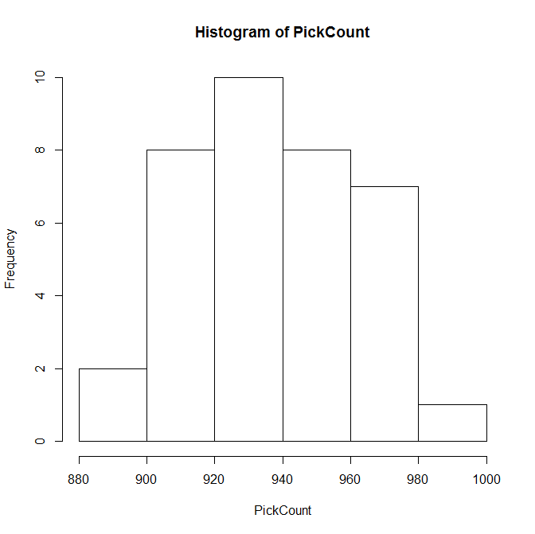

88 | 65

90 | 9236679

92 | 0133445567

94 | 050226779

96 | 1257907

98 | 6

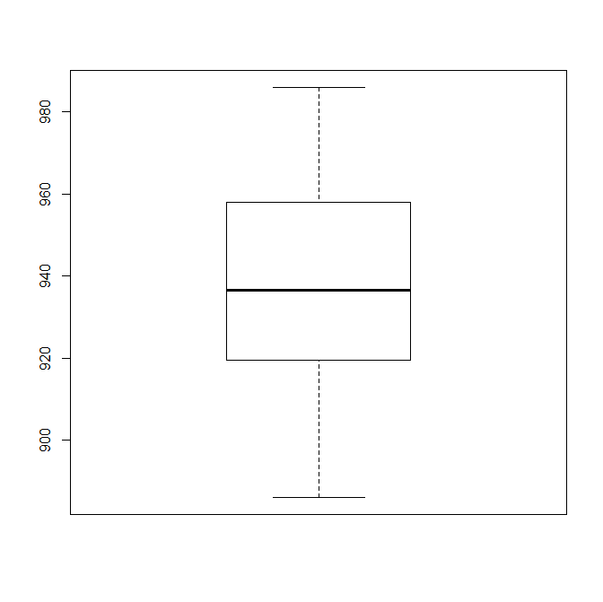

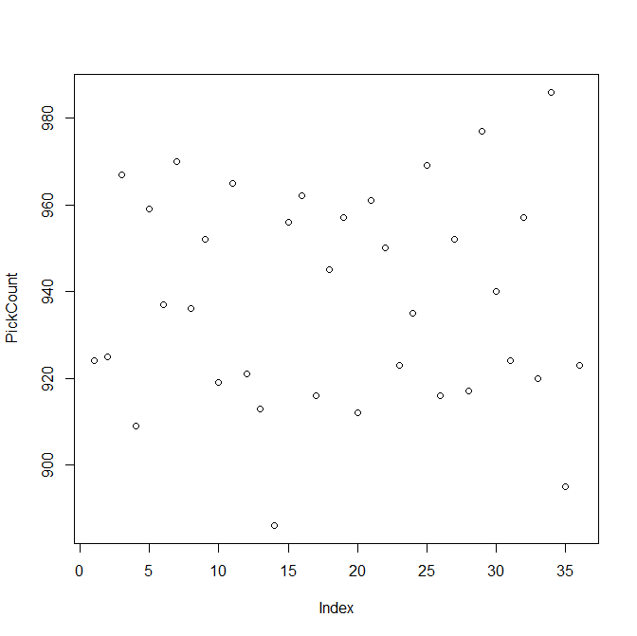

There are no outliers. The data is very slightly skewed to the right. The data is fairly normal.

b) That data is acceptable for the t or z procedure. Since the data is not significantly different from normal and is symmetrical with only mild outliers, we can use t procedure when population standard deviation is not given, and z procedure when the population standard deviation is given.

c)

mean= 938.2222

sd= 24.2971

se= 4.049517

d)

90 percent confidence interval:

931.3803 945.0642

Code for 7.36

#a,b

hist(PickCount)

stem(PickCount)

boxplot(PickCount)

plot(PickCount)

summary(picks)

iqr=957.5-919.8

q1=919.8-1.5*iqr

q1

q3=957.5+1.5*iqr

q3

n=36

# c

xbar=mean(PickCount)

xbar

sigma=sd(PickCount)

sigma

se=sigma/sqrt(n)

se

# d

t.test(picks,mu=.95,conf.level=.9)